Thursday Bidding Tips 10 Board 3 played on 28/6/2018 Burns Pairs
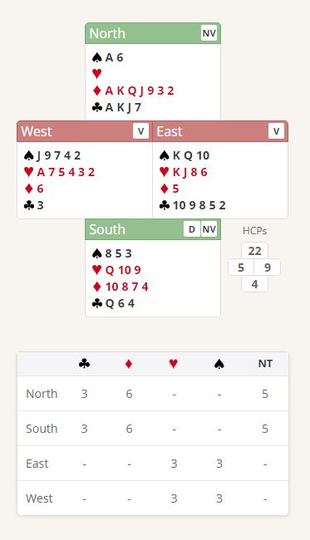
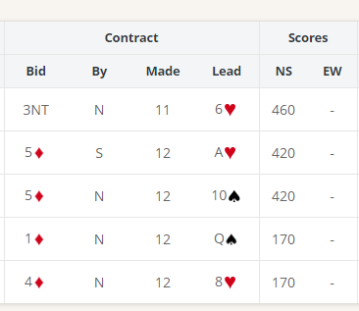

Suggested Bidding
N | E | S Dealer | W
 |  | Pass | Pass
2C | Pass | 2D | Pass
3D | Pass | 4D | Pass
5D | Pass | Pass | Pass
Pass

- Norths Bid of 2 Clubs shows 20 plus points and an unbalanced hand
- Souths reply of 2 Diamonds shows 0-7 points. (2 Diamonds is an artificial bid. It has nothing to do with diamonds. The message is that responder is not interested in bidding slam (ie. bidding to the 6 or 7 level)).
- North with 22 Points and 7 Diamonds bids 3 Diamonds to show at least a 5 Diamond suit
- South with 4 points bids 4 Diamonds Shows at least 3 card fit and is a game enquiry (We have at least-23-24 Points is game on?)
- North with 22 High Card Points and void in hearts (27 Total Points) bids 5 Diamonds (Not enough for slam bidding and South has already said that slam is not on)

Suggested Lead from East 6 Hearts (4th Of Strongest Suit) or 10 Clubs (top of Sequence)

Further notes about Strong Opening bidding http://www.nzbridge.co.nz/user/inline/1649/NZB%20Beginner%2010%20-%20Student%20Notes.pdf

